

**PRE BOARD EXAMINATION 2019 MARCH**

Bachelor Level/First Year/I Semester Full Marks: 50

Bachelor in Computer Application (BCA) Pass Marks:

Computer Fundamentals and Application (CACS101) Time: 2 Hr. 50 Min

Examination Date: 27th, Mar, 2019

*Candidates are required to give their answers in their own words as for as practicable.*

*The figures in the margin indicate full marks.*

**SET B**

**GROUP B**

**Attempt any SIX Questions: [6X5=30]**

1. What do you mean by Computer Architecture? Describe the functional components of computer architecture with block diagram.
2. Define Software. List and explain the types of Software.
3. What is memory? What is the unit of memory representation in a computer?
4. Differentiate between SRAM and DRAM.
5. Define DBMS. Explain the different database models with their merits and demerits.
6. What is Antivirus? What are the functions of Antivirus?
7. Define Computer Network. Explain the different types LAN topologies with their advantages and disadvantages.

**Group C**

**Attempt any TWO Questions: [2X10=20]**

* 1. You are provided following data:  
       
     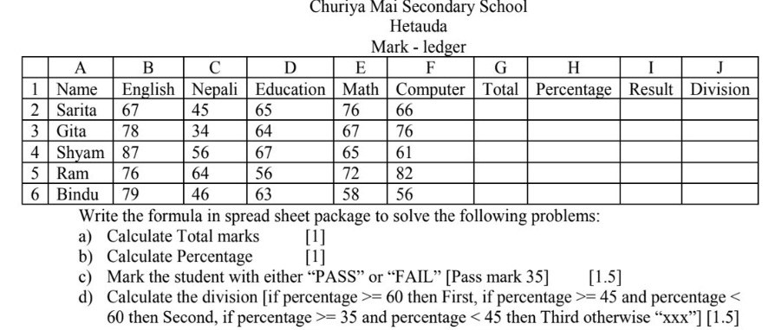
  2. Explain the features of Font control dialog box in word processing package. [5]

1. Write down the importance of OSI model? Explain all the layers of OSI.
2. Describe computer virus. Illustrate the types of computer virus.